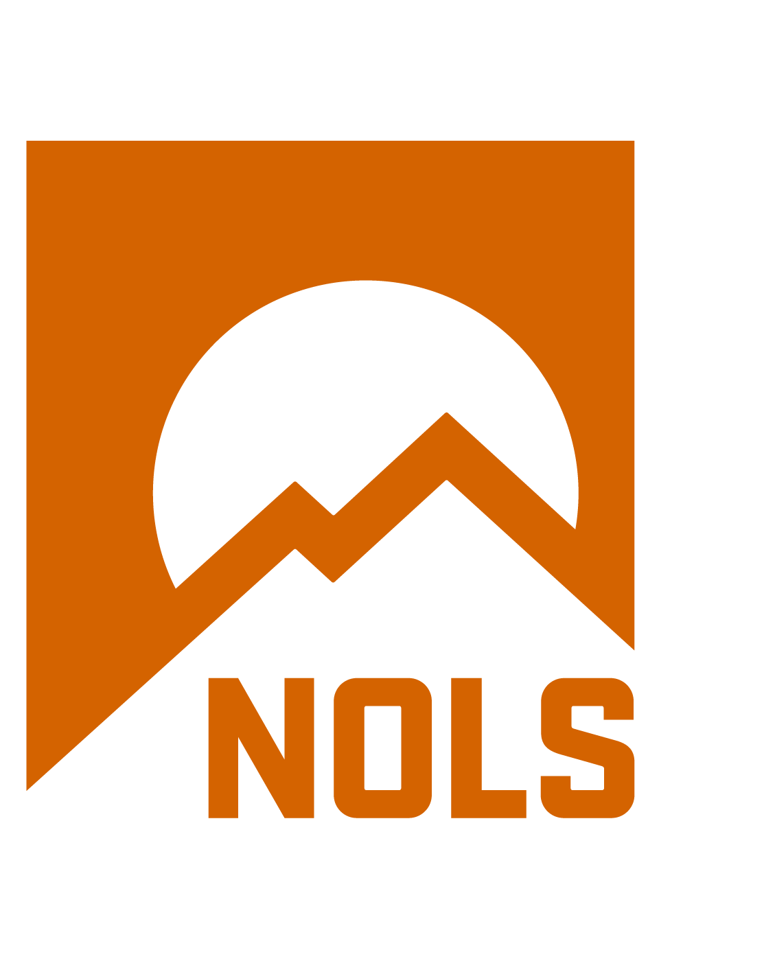
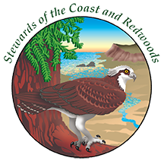

WILDERNESS FIRST AID (WFA)

Sponsored by
Stewards of the Coast and Redwoods (Stewards) &
NOLS Wilderness Medicine
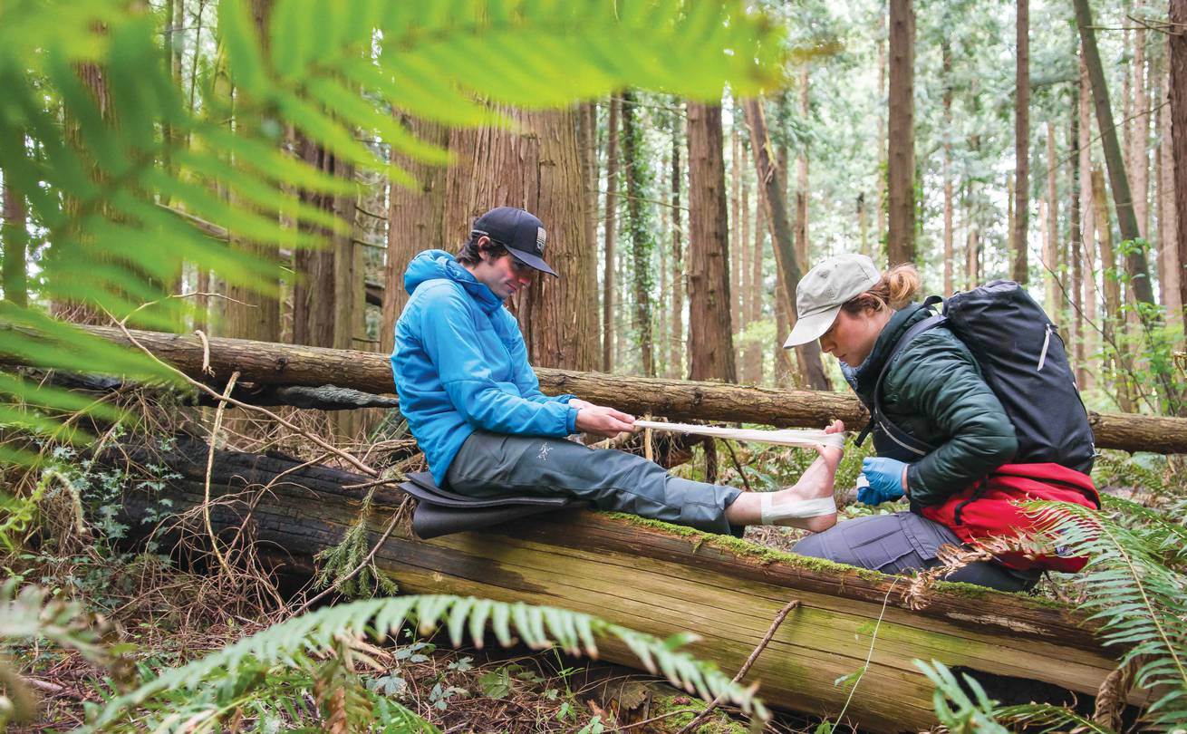

DATES: JUNE 13 & 14, 2020
COST: $240 – Stewards members, $300 – non-members
LOCATION: Armstrong Redwoods State Natural Reserve
17000 Armstrong Woods Road, Guerneville, CA 95446
INSTRUCTOR: Daniel De Kay, WEMT

*Please see Student Logistics below for additional information on course location

COURSE DESCRIPTION
Whether spending time in the backcountry is your passion or your profession, you should never have to ask, "What do I do now?" Prepare for the unexpected with this fun, hands-on introduction to wilderness medicine.

If you like to take short trips relatively close to medical resources, work at camps or lead wilderness trips, enjoy weekend family outdoor activities, or recreate outdoors, this course is for you.

You'll learn the Patient Assessment System, how to provide effective first aid treatments for injuries and illnesses common in the outdoors, how to manage environmental emergencies, and how to make appropriate evacuation decisions. You will spend half your time practicing skills and participating in realistic scenarios.

NOLS Wilderness Medicine's course is approved by such organizations as the American Camp Association, the United States Coast Guard, and other states as well as federal agencies.

Upon successful course completion you will earn the following NOLS Wilderness Medicine certifications: Wilderness First Aid, Epinephrine Auto-injector, and on courses with the CPR module, Adult and Child CPR & Airway Management.

CLASS FORMAT AND PERSONAL PREPAREDNESS
Check-in is 7:45 AM on the first day. Course days run from 8:00 AM to 5:00 PM. All course materials will be provided on the first morning of the course.

The class format is classroom lectures integrated with practical scenarios, case studies, and skills practice sessions. Attendance is required at all classes.

Scenarios and practice sessions will take place both inside and outside. Bring outdoor clothing appropriate for lying on the potentially wet, snowy, or cold ground playing the role of both rescuer and patient.

Frequently stage (moulage) blood and make-up are used to enhance the realism of a scenario. The classroom environment generally lends itself to a pair of comfy shoes and a camp chair.

PACKING CHECKLIST
- Notebook and pencil or pen
- Watch with a second hand or digital second
- Sunglasses and hat
- Water bottle
- Light day pack
- Waterproof outerwear top and bottom
- Light hiking boots or sturdy shoes
- Clothing layers that allow you to be comfortable in a variety of weather conditions
- Slippers or comfortable shoes for classroom time (optional)
- Camp chair for classroom time (optional)
COURSE OUTLINE
For the full course outline, visit the NOLS Wilderness Medicine WFA course page.

REGISTRATION AND TUITION PAYMENT

Tuition payment in full is required to reserve your spot in the course. You can register online by following this link (we accept Visa or Mastercard).

The tuition fee includes instruction, handouts, a field pocket-guide, equipment use, and certification. A full refund will be given if we need to cancel the course for any reason.

Course Tuition: $235 non-members Members of Stewards receive a 20% discount for a course tuition of $188.
Memberships available online

WAFA/WFR/WEMT RECERTIFICATION NOT OFFERED FOR THIS COURSE.
Because this is a one-instructor course we are NOT able to offer recertification.

The Wilderness First Aid (WFA) course is an introductory course for individuals with no prior knowledge and generally, does not include CPR.

The preferred way to recertify your certification is to enroll in a Wilderness First Responder Recertification course (WFR-R), or through our Hybrid WFR Recertification course, which adds an online component in addition to traditional scenarios and skills.
These courses are specifically designed for students needing recertification.

More information can be found by following the links below:
WFR-R
Hybrid WFR-R

NOLS WILDERNESS MEDICINE STUDENT AGREEMENT
Please download the NOLS Student Agreement and read it carefully as it affects your legal rights.

Bring the two-page signed document to the first day of the course. If you are a minor, a parent or guardian must sign the document as well. Without a signed document, you cannot participate in the course. NOLS Wilderness Medicine participants, including minors, will have unsupervised free time throughout the course. Any activities during the free time are not part of the NOLS Wilderness Medicine program and are at the sole risk of the participant.

NOLS WILDERNESS MEDICINE POLICIES

Cancellations
If you cancel or withdraws from a course:
- Greater than or equal to 30 days prior to the course start date, Stewards will retain a $35.00 administrative fee. The remainder of tuition collected to date will be refunded.
- Within 30 days of the course start date, tuition is non-refundable and non-transferable as per the following:
  - WFA, WFR-R, WMPP – loss of full tuition.
  - WFR, WAFA, WUMP – loss of course deposit.
- Once the course begins, no refunds will be awarded. All course registrations are non-transferable.

Pets
Pets are not allowed at the course site. This includes leashing them outside. Any student bringing a pet to class will be asked to leave until the pet is safely situated in a kennel or other facility. No exceptions.

Service Animals
Please contact the Stewards (707) 869-9177 if you intend to bring a service animal to the course.
Alcohol, Drugs, Tobacco & Weapons
No alcohol, no drugs, no tobacco, and no weapons are allowed in the classroom.

COLLEGE CREDITS
Pre-Course Access to College Credit
The WFA course is pre-approved for 0.5 credit through Western State Colorado University or an additional cost. Interested students must initiate registration and payment for credit by contacting Western at least 30 days prior to the course start. More information can be found here.

On-Course Access to College Credit
The WFA course is pre-approved for one semester hour credit through the University of Utah for an additional cost. If you are interested in receiving college credit, please ask your instructors on the first day of class for the necessary information.

STUDENT LOGISTICS
Meals and Lodging
There is no meals and lodging package available for this course.

Camping: Stewards operates Bullfrog Pond Campground, which is in Austin Creek State Recreation Area – adjacent to Armstrong Redwoods State Natural Reserve. Reservations can be made at www.hipcamp.com. Information is available on our website.

For other accommodations visit www.russianriver.com

Travel
Take Highway 101 north of San Francisco to the River Road exit on the north end of Santa Rosa. Turn left and stay on River Road until you get to the town of Guerneville. Turn right at the second signal, which is Armstrong Woods Road. Take Armstrong Woods
Road until you arrive at the park entrance. Enter the park (fees not necessary) and stay to your right until you get to the picnic area. Then
continue to the right and you will end up in the parking lot where the Stewards of the Coast and Redwoods office and Volunteer Center
conference room are located.

Link to Map

CONTACT INFORMATION
Please contact Stewards with any questions or concerns you may have.

Course Host:
Office Hours: 9-5, M-F
Phone: (707) 869-9177
Email: stewards@stewardscr.org
Fax: (707) 869-8252
Website: www.stewardscr.org

NOLS Wilderness Medicine:
Office Hours: M-F from 8am-5pm MST
Phone: (866) 831-9001
Email
Website

